User Manual for Executive -[Client Name]

Microsoft® Office Enterprise Project Management Solution
EXECUTIVE



AstroWix Corporation
Email: info@astrowix.com



AstroWix India Project Solutions Pvt. Ltd.
Delhi NCR Office
A-57, Sector 16
Noida 201 301, INDIA
Phone: +91 120 431 5760, Fax: +91 120 431 5766
Email: info@astrowix.com
Bangalore Office
484, II Cross, 25th Main
BTM Layout II Stage
Bangalore - 560 076, INDIA
Phone: +91 80 2678 5916
Email: info@astrowix.com
TABLE OF CONTENTS
INTRODUCTION 4
Process Flow Diagram 5
Planning Process 6
1. Project Manager Role – Create the Project plan 6
Connect MS Project (log on) to Project Server 6
Publish Project plan with appropriate Template 8
Viewing Project Web Access Home Page 13
Viewing Project Center 13
Viewing Project Detail 14
2.Project Manager Role – Approve resource assignments 15
3. Project Manager Role – Verify the approved status on MS project 17
Connect MS Project (log on) to Project Server 17
Viewing all Resources and Checking their availability 19
Analysis of Data thorugh Data Analysis 20
Viewing Project Workspace 21
Alert or remind me of changes with e-mail notifications 23
About alerts and reminders 23
Set notifications for yourself 23
Set notifications for your resources 25

INTRODUCTION

Audience:

This manual is meant for the users at [Client Name]. Users of this manual should have basic working knowledge of computers.

Purpose of this document:

The purpose of this document is to provide an interface between the user and the EPM. It will help users to update the progress of various activities, view the Schedule of the projects, view all the reports related to [Client-DOMAIN], publish and track the baseline plans for a particular project or a group of project.

Scope:

It provides operating knowledge of the Web based Enterprise Project Management System for [Client Name]

Process Flow Diagram
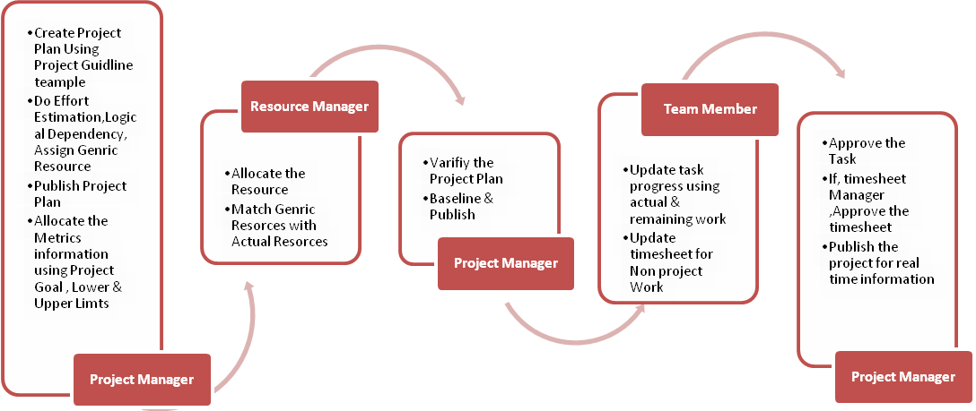

Viewing Project Web Access

1.Home Page

- Open IE -> Type the PWA url in the address bar
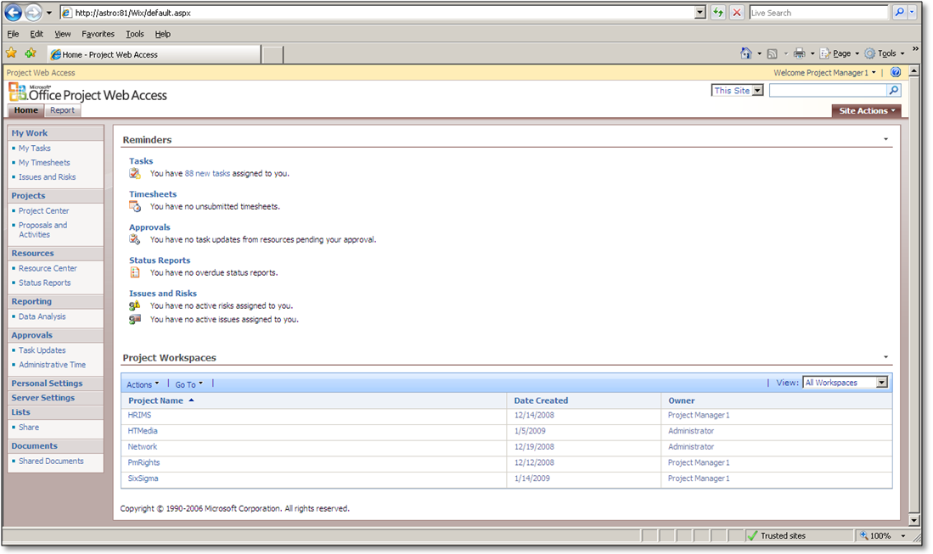
Reminder Space
Quick Launch
Project Workspace (All project related documents / risks / issues is shown here)

Viewing Project Center

In order to see a portfolio of projects one has to click on the “Project Centre” under Projects in the Quick Launch

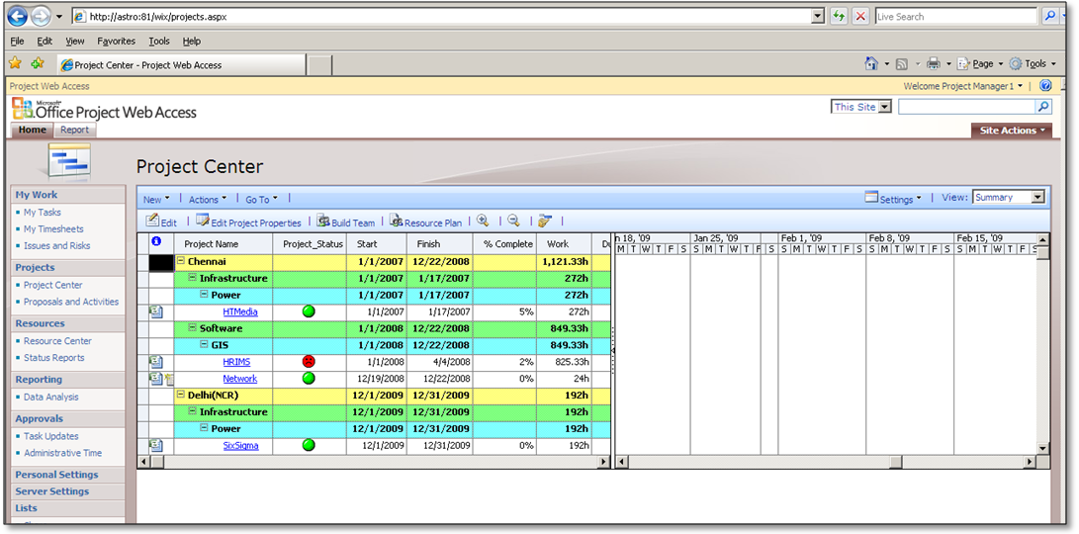

Views
Based on Organization Parameters like Location / project categorization/ Priority one can see the projects as shown in figure shown above. The basic View is the Summary View shown on right side.

Viewing Project Detail

In case management wants to see the details of a project, he simply has to click on the project.

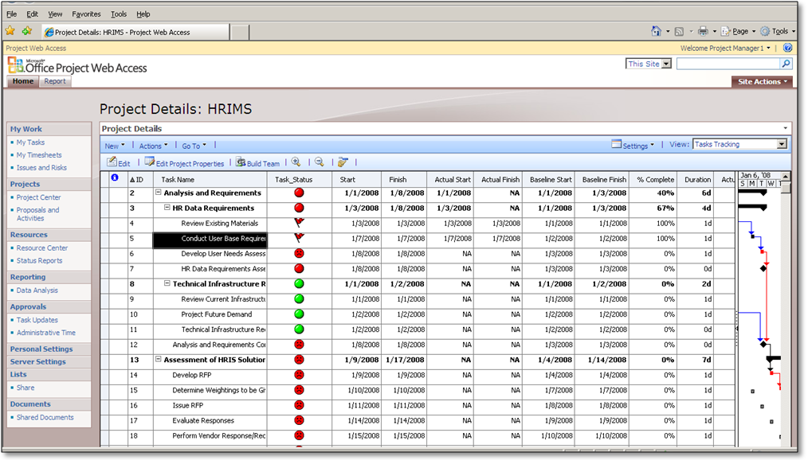

Resource Center
For viewing the resources
- click on Resource Center, as shown in the following figure.
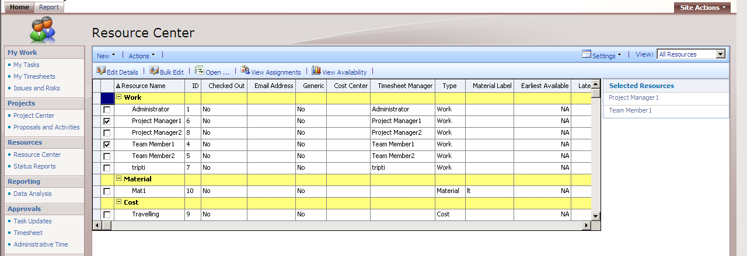

- After clicking all the resources will be displayed under the Resource Center.

Analysis of Data thorugh Data Analysis
- If the management desires to view the Customized Data Analysis Reports
- Click on “Data Analysis” on the Quick Launch of “Home” tab on the website.

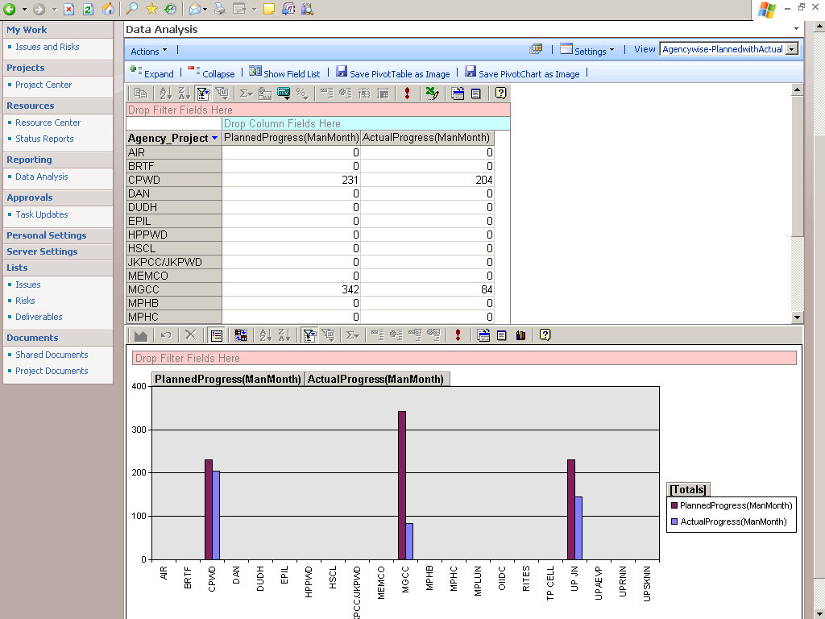

5.Viewing Project Workspace

  - Login to Project Web Access.
  - On the home page, a list of project workspaces of which you are a project manager are displayed.
  - Click on the project workspace for which the document, risk or issue is to be added.

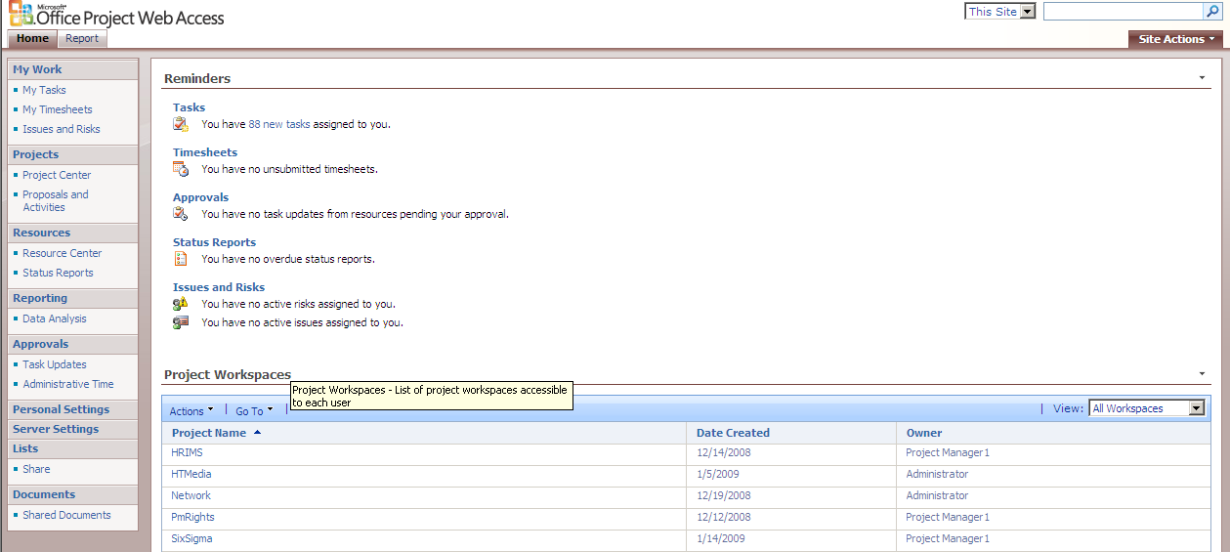
  - A new window opens.
  - Add the required information related to the project in that workspace
